

Spectrolipi guide

Overview:
Bioacoustics researchers, birders, and machine-learning practitioners use Spectrolipi to visualize sound, annotate spectrograms, and prepare high-quality datasets for acoustic analysis.

Features:
- Spectrogram playback with adjustable colormap, gain, and zoom
- Create, edit, import, and export annotation boxes
- Quick annotation tools (SCC & Repeat annotation) for repeated sound patterns
- Species selection with predefined or custom lists
- Basic sound editing: cut, silence, filters, normalize, undo
- Manage file level Metadata
- Export ML ready clips auto sorted by species
- Local only processing for full data privacy
- Xeno-canto integration for uploading annotations.

Links:
Spectrolipi Tool: Spectrolipi (https://spectrolipi.com/)
Report issues or feature requests: Issues (https://github.com/nishantnnb/spectrolipi/issues)

A] Main screen.

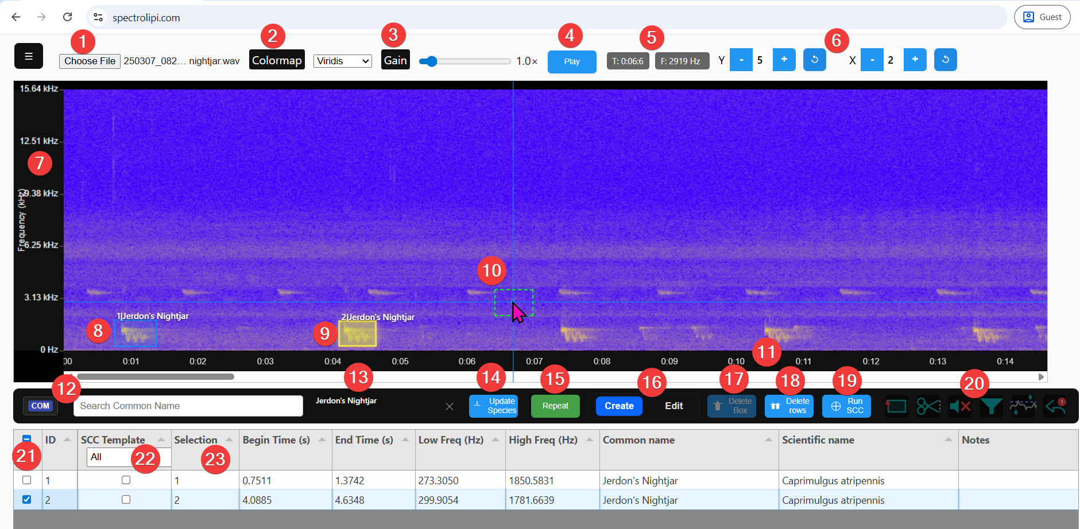

- File selector: To select a sound file for annotation (wav, mp3, etc). Caution: Do not load too large file (> 10 mins duration).
- Colormap: To select color scheme for the Spectrogram.
- Gain: To change brightness/contrast of the Spectrogram.
- Play/Pause: Play and pause the playback of spectrogram.
- Mouse coordinates with respect to the spectrogram axis.
- Zoom controls: Control zoom on for Y and X axis. Also, buttons to Reset Zoom level. Note: Y min is always Zero.
- Y axis: Frequency in kHz. Scale can be controlled with Zoom controls.
- Canvas (with an annotation box): Spectrogram generated from the sound file is displayed here. Annotation boxes can be drawn over it. Given is an example of an annotation box with label. Label contains serial number & Common name. Note: Horizontal axis can be scrolled with mouse scroll wheel.
- Canvas (with a selected annotation box): Annotation box(es) can be selected on the spectrogram as well as by selecting the rows in the grid.
- Canvas (with an annotation box template during Repeat mode): When repeat mode is selected, the template annotation box is displayed with dotted edges.
- X axis: Time axis. Important note: Click on X axis area to resume the playback from that point.
- Species selector: Select species here to draw annotations in create mode. This control is disabled in Edit mode. It had a three-way toggle button to select the species from Scientific name or Common name or eBird quick entry code.
Once species is selected, it is shown on the right side of that control.
List of species in this control is referred from species-data.js which is a json file created with the script csvtojs.py. csvtojs.py converts species list ‘species.csv’ in required json format. User can upload own species list with Manage species list option in the hamburger menu.
- Selected species: When a species is selected with the species selector, it is displayed here.
- Update species: This option is used to update species in the selected rows. Select required rows in the grid with row selector. Select / change species in Species selector. Press Update species button. On confirmation, species is changed for the selected rows.
- Repeat mode: For repeated sounds in the spectrogram, Repat mode helps in quick annotation. When the button is pressed, system creates a template box with same coordinates of last draw annotation and user can left click to place it at appropriate place. To exit the Repeat mode, click the Repeat button again to toggle. Note: Repeat mode is disabled in Edit mode.
- Create mode & Edit mode: These modes are toggled and either of the modes will be active.
Create mode: Select required species in the species selector. On the required area of Spectrogram, drag the mouse to create a box. Mouse lines (Vertical & Horizontal) are shown on entire canvas wherever the mouse moves which helps as a guide to create accurate boxes. An entry will be created in the grid. Common name. & Scientific name will be automatically inserted in the grid based. Press Right click on mouse to cancel / delete the last created box. For next boxes, same species will be defaulted. Change the species (if required), before creating a new box.
Edit mode: When this mode is selected, we can’t create a new box but can edit existing boxes.
Mouseover near the boxes will auto highlight (yellow color) the nearby box. Click to select it. Once selected, the box will be displayed in edit mode, and its edges can be modified. The modified coordinates are synchronized in parallel in the grid. When we drag from inside of a selected box, the box can be moved to desired position. For editing next box, click on that box to start editing.
- Delete Box: When in Edit mode, select a box and press Delete Box button (or press ‘Delete’ of ‘D’ key) to delete it.
- Delete row: Select the required rows in the grid with row selector and press Delete rows button to delete these rows (& the boxes).
- Run SCC: SCC tool helps in automation of drawing boxes of similar sounds. This process is not an accurate process and depends on lots of factors like background sounds, similar sounds, parameters chosen, etc. And it may become iterative process to achieve near to realistic detections. To make the process less complex and less iterative, we have provided results with 3 different presets as explained below.
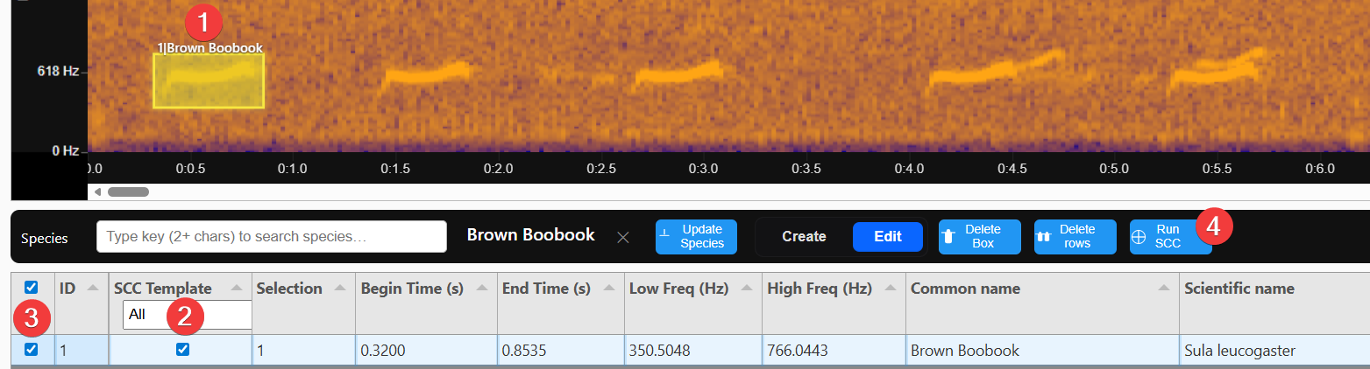
- Create an annotation box as a template sound.
- Select the annotation row as a SCC template.
- Select the row. (Only 1 template is allowed to be selected for SCC at a time)
- Press Run SCC button.

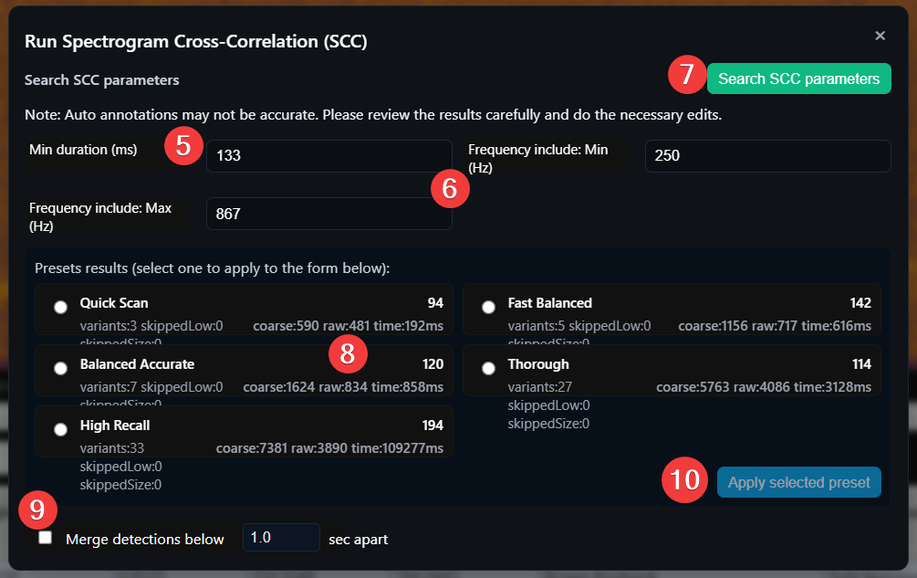
- Min duration: Min duration on the spectrogram which will be qualified as a detection.
- Default: Template duration / 2.
- Min & Max frequency: Template will be matched between these frequencies only.
- Default: Template min & max frequencies - / + 100 Hz.
- Search SCC parameters: There are complex parameters to run the SCC in background. Search SCC parameters apply those parameters on 5 predefined presets and show number of detections for each template. This process may take time.
- Once calculations are over, system shows number of detections for each preset. User can select appropriate preset to apply.
- Merge detections below X secs apart: If selected, the detections which are less than X sec apart will be merged into single detection.
- Apply selected preset: Rows & boxes will be created as per the applied preset. If merge detections (9) was selected, you may find less number of boxes compared to displayed detections. All newly created rows will be selected by default.
Once done, it is recommended that to review the result and perform edit / delete operations as required.
- Basic sound editing tools: Select timespan, cut the selection, Silence the selection, High pass / Low pass, Normalize and undo (only last 1 edit).
- Row selector: To select the rows for operations on the grid rows like delete, edit, etc.
- SCC Template: Selected row is considered as a template to run SCC.
- Grid: Contains rows for each box. Rows Created / Edited / Deleted / Imported with related process. Standard columns can’t be edited manually, except the ‘Notes’ column. Also, the additional columns inserted during ‘Upload annotations’ will be editable. All columns can be sorted by clicking the column heading.

B] Hamburger Manu:
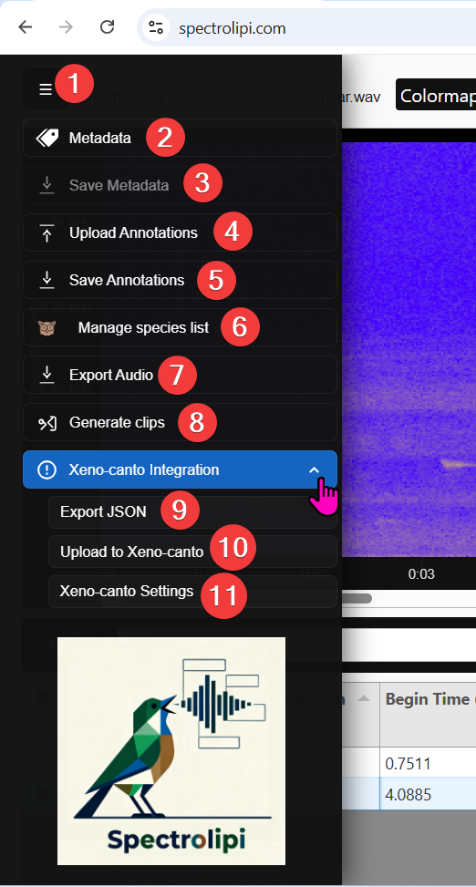

- Hamburger menu: To open the panel of hamburger menu.
- Metadata: To maintain the metadata at the file level. This button is enabled only if sound file was selected. All fields are non-mandatory and self-explanatory . Target species can be selected like Species selection.
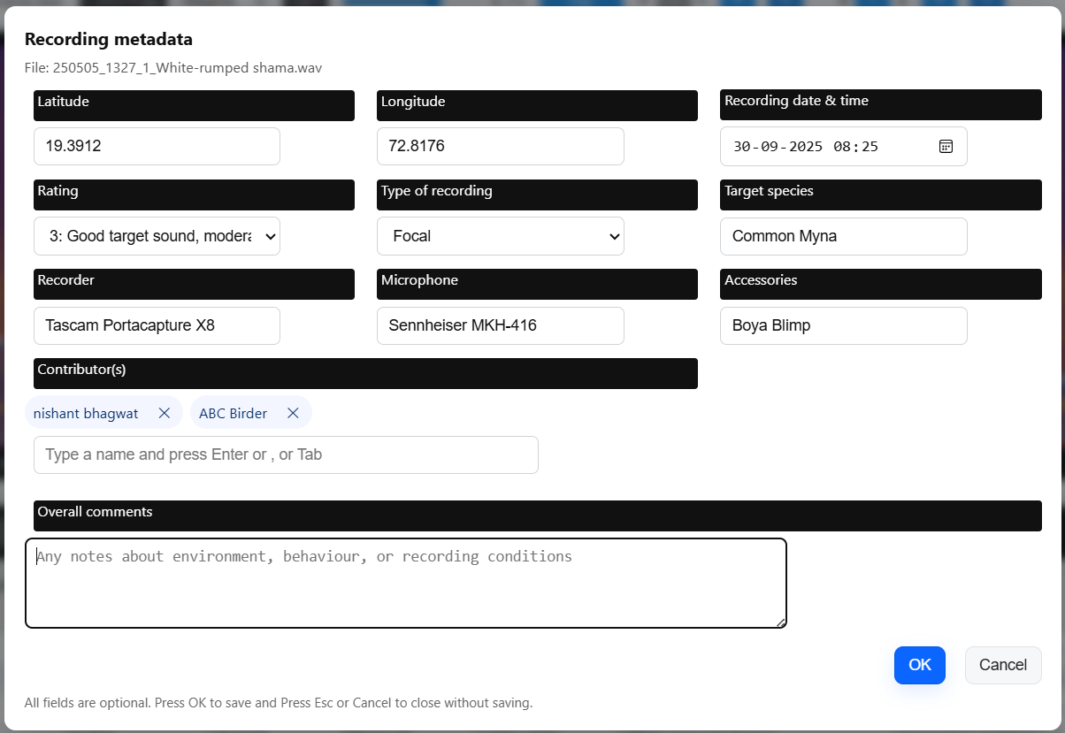

- Save Metadata: This button will save the metadata in tab separated text file in ‘Downloads’ folder – suffixed by ‘_Metadata’.
- Upload annotations: This option helps to load previously created annotations in this tool or tools like Raven.
    - If the standard column names are matching, those will appear properly under respective columns in the grid. ID and SSC related columns need not be imported. If ‘selections’ column is not present, system will auto create the numbers in series. In the imported files, if there are any additional columns which are not matching with the existing columns in the grid, those will be inserted in grid after the standard columns in the grid. Cells in all additional columns will be editable.
    - Once the rows are loaded, and if proper coordinates are available for boxes, boxes will be displayed in the Spectrogram.
    - If we had already drawn few boxes manually, there will be existing rows in the grid. In such case, if we import annotations, system will ask following options:
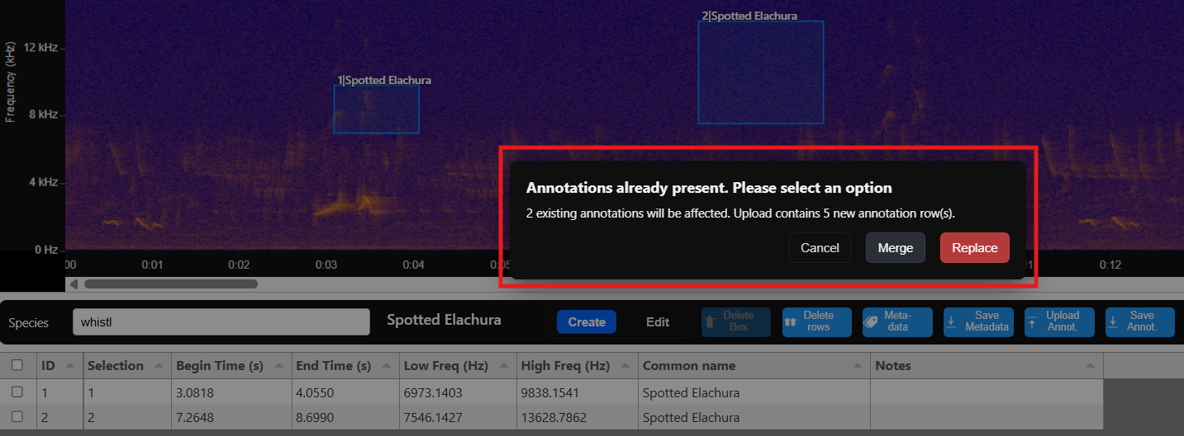

    - Cancel: Import will be cancelled.
    - Merge: Existing rows will be kept and imported rows will be inserted after those rows.
    - Replace: Existing rows will be deleted, and system will keep only imported rows.
- Save annotations: This button will save the annotations in tab separated text file in ‘Downloads’ folder – suffixed by ‘_annotations’. All columns in the grid will be available in the file except the ID column & SCC related columns. Additionally, ‘View’ & ‘Channel’ columns with default value = 1 will be available to support import in Raven software.
- Manage species list: With this option, user can upload own species list which will be available in Species selector.
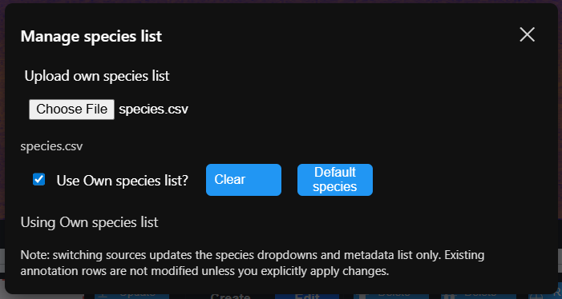
  - CSV file format: Key, Common Name, Scientific Name. Key can be shortform used for filtering the species easily similar to eBird quick entry.
  - Select the CSV file and select the checkbox ‘Use Own species list’. If checkbox is not selected, default species list will be used.
  - Clear button: To clear the selected file.
  - Default species button: To download the default species list which can be modified and used as an own species list by uploading again.
  - Note: When browser is closed and reopened, we need do upload own species list again.
- Export audio: Export the audio if it was edited in Spectrolipi with the sound editing tools.
Select appropriate Sample rate & Bit depth during export.
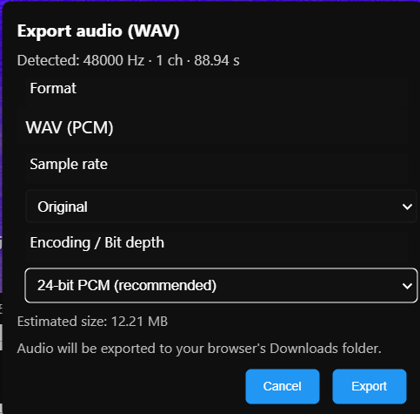
- Generate clips: With this option sound clips can be generated based on the annotations for machine learning.
Keep the sound files and the related annotation files in the same folder. Name of the sound file and related annotation file should be same. Sound clips are generated and saved in the selected Destination folder.
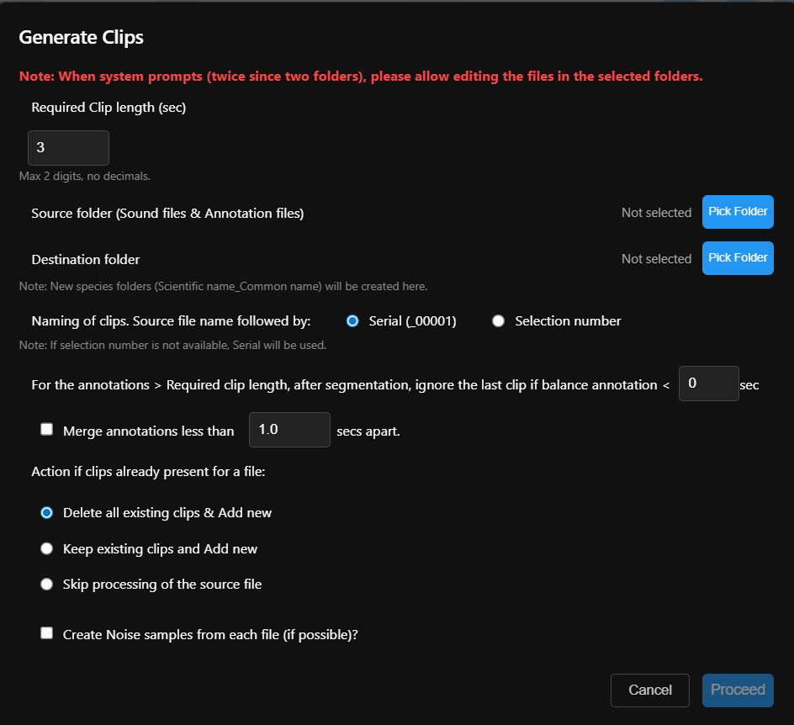
Key Settings
- Clip Length: Enter required duration in seconds (1-99, integer).
- Naming: Use serial (e.g., filename_00001.wav) or selection number from annotations.
- Ignore Last Clip: Skip final segment if shorter than specified balance (default 0 sec).
- Merge Annotations: Combine same-species annotations closer than set gap (default 1.0 sec).
- Conflict Handling: Delete existing clips and add new; keep existing and add new; or skip processing.
- Noise Samples: Optionally extract one annotation-free noise clip per file.

- Xeno-canto integration (Export json): To download the json file of the annotations. We can upload it manually in Xeno-canto website.
- Xeno-canto integration (Upload to Xeno-canto): Annotations are directly sent to Xeno-canto for the respective file number maintained in the Metadata. Note: Fill up the required matadata first before using this option and make sure that settings are correct (11).
- Xeno-canto integration (Xeno-canto settings): Maintain API key, Annotator display name, Annotator Xeno-canto ID, API end point. Note: Settings will get blank for the reasons like browser is reinstalled or history is cleared.

C] Other notes:
1) If Annotations / Metadata was not saved before closing or refreshing the browser, it can be recovered if the same sound file if reopened immediately. System will provide option to recover. If any other file is opened, no data can’t be recovered.
2) If you want to add additional columns in the grid, prepare a template txt file with standard as well as additional columns (and without any rows). Use upload annotations option and the additional columns will be added to the grid.
3) To add species to the default species list, download the CSV of default species from Manage species list option. Update the file and import again and select ‘Use own species list’ option.
4) If row(s) are selected, corresponding boxes gets highlighted in the canvas.
5) When a box is selected in Edit mode, corresponding row gets selected in the grid.
6) SCC Run no. & SCC score % columns in the grid can be used to appropriately filter and delete the rows having low SCC score %.

